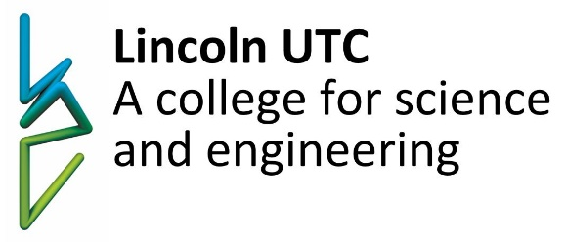

Lincoln UTC Post-16 Entry Requirements

To study 4 A-levels:
Minimum of 8 GCSE grade 5s including mathematics, English and additional or triple science.
To study 3 A-levels:
Minimum of 6 GCSE grade 5s including mathematics and additional or triple science.

- Biology requires a minimum grade 6 at GCSE biology (for combined science students a minimum grade 6 in biology components) AND a minimum grade 5 in GCSE mathematics.
- Chemistry requires a minimum grade 6 at GCSE chemistry (for combined science students a minimum grade 6 in chemistry components) AND a minimum grade 5 in GCSE mathematics.
- Physics requires a minimum grade 6 at GCSE physics (for combined science students a minimum grade 6 in physics components) AND a minimum grade 5 in GCSE mathematics.
- Engineering (BTEC Level 3 - equivalent to 3 A levels) requires a minimum of 5 GCSEs at grade 5, including a grade 5 in mathematics. No prior knowledge of the subject is required but applicants should have an interest in pursuing a career in engineering.
- Business (BTEC Level 3 - equivalent to 1 A level) requires a minimum of 5 GCSEs at grade 5 and above. No prior knowledge of the subject is required.
- Computer Science requires a minimum grade 5 in computer science or a background in computer programming.
- English Literature requires a minimum grade 5 in both English literature and English language
- Mathematics requires a minimum grade 6 in mathematics.
- Product Design no prior knowledge of the subject is required.


Working together to develop the skills
for success in industry and university
Specialists in science, technology, engineering and maths
in partnership with industry and the University of Lincoln

